
A Project Report On

“ TRACK AND TRACE SUPPLY CHAIN”
Batch No: 213
Sl. No. | Roll Number | Student Name
1 | 20211CSE0878 | Aditya kumar Jha
2 | 20211CSE0862 | Sourav Bhowmick
3 | 20211CSE0849 | Abhinav Kumar Singh
4 | 20211CSE0830 | Aaditya Kumar

School of Computer Science
Presidency University, Bengaluru.
Under the Supervision
Dr. Abdul Khadar A
School of Computer Science, Presidency University, Bengaluru

CONTENTS
- Introduction
- Literature Review
- Objectives

4. Methodology
- Timeline for Execution
- Expected Outcomes
- Conclusion
- References

1.INTRODUCTION

Our project on developing a Track and Trace Solution is timely and highly relevant in today’s global marketplace. By focusing on transparency and authenticity, you’re addressing critical consumer concerns and potential supply chain vulnerabilities. Here are a few key considerations and suggestions to enhance your project:
Key Components to Consider:
- Technology Integration:
    - IoT Devices: Use sensors and RFID tags for real-time tracking.
    - Blockchain Technology: Implement blockchain for immutable record-keeping, ensuring data integrity and security.
    - Cloud-Based Solutions: Utilize cloud storage for centralized data management and accessibility.
- User Interface:
- Develop an intuitive interface for stakeholders, including manufacturers, distributors, and consumers, to access tracking information easily.
- Data Analytics:
- Incorporate analytics tools to identify trends, monitor supply chain performance, and predict potential disruptions.
- Compliance and Standards:
- Ensure your solution adheres to industry regulations and standards for data privacy and security.
- Consumer Engagement:
  - Create a mechanism for consumers to verify product authenticity via QR codes or mobile apps, enhancing their trust in the brand.
Benefits of Your Solution:
  - Enhanced Transparency: Real-time tracking fosters accountability among all parties in the supply chain.
  - Reduced Fraud: Authenticity verification reduces the risk of counterfeit products entering the market.
  - Operational Efficiency: Automating tracking processes minimizes errors and speeds up logistics.
Potential Challenges:
  - Adoption Resistance: Address potential resistance from stakeholders accustomed to traditional methods.
  - Initial Costs: Consider the investment needed for technology implementation and training.
Next Steps:
  - Pilot Program: Implement a pilot with a select group of products to test the system's effectiveness. - Feedback Loop: Establish a system for gathering feedback from users to continuously improve the solution.
By prioritizing transparency and authenticity, your Track and Trace Solution has the potential to revolutionize supply chain management and significantly enhance consumer trust.

2. LITERATURE REVIEW
The evolution of supply chain tracking technologies has primarily relied on barcode scanning and RFID, providing basic visibility but facing challenges in scalability across multiple distribution points. Current supply chain transparency suffers from fragmented data systems, leading to poor integration (Chopra, 2019). Blockchain technology offers a decentralized ledger for end-to-end traceability, enhancing product authenticity (Saberi et al., 2019). Automated Identification and Data Capture (AIDC) methods, including QR codes and smart sensors, facilitate real-time tracking, though they encounter infrastructure and integration challenges (Heese, 2018). Global supply chains face complexities that contribute to counterfeiting and delivery delays (Christopher, 2016). Real-time tracking systems using IoT sensors can significantly reduce spoilage for perishable goods (Wang et al., 2020). Cloud-based solutions improve visibility and collaboration across stakeholders (Lobo, 2020). However, existing methods often lack effective integration, leading to high costs and technical complexities (Sweeney, 2013).
Advantages:
- Improved transparency and traceability through blockchain.
- Enhanced real-time tracking capabilities with IoT and AIDC.
- Greater efficiency and reduced spoilage in logistics.
Disadvantages:
- High infrastructure costs and integration challenges.
- Data fragmentation leading to inefficiencies.
- Limited effectiveness of individual technologies when not integrated.
Here are some Summarise of research paper that we use for literature review
A Secure RFID-based Track and Trace Solution in Supply Chains

W. He, N. Zhang, P. S. Tan, E. W. Lee
Singapore Institute of Manufacturing Technology
71 Nanyang Drive Singapore 638075
{whe, nzhang, pstan, ewlee}@SIMTech.a-star.edu.sg

Summary

A Secure RFID-based Track and Trace Solution for supply chains is covered in the Research Paper, with an emphasis on improving visibility and traceability while maintaining security. Important points consist of:

- EPCIS Database: The system uses a MySQL-based EPCIS (Electronic Product Code Information Services) repository that records RFID events in XML format and enables SOAP/HTTP querying. For product tracking, it uses IDs such as GLN, GRAI, and SSCC
- Development of the Prototype: To illustrate an Order Management (OM) procedure involving a Manufacturer and Supplier, a prototype was created. It shows how goods can be safely traced to reduce hazards like counterfeiting by simulating RFID readers for shipping and receiving.
- B2Bi Gateway System: By controlling the flow of business information and guaranteeing security via a Circle-of-Trust (COT) paradigm, the system makes it easier for supply chain participants—SMEs in particular—to collaborate.
- Security Measures: The system has two security levels: one for protecting data between RFID tags and readers and another for regulating information exchange between supply chain actors.
- Future Work: The report ends with a request for additional improvements to accommodate additional procedures and kinds of RFID readers/tags, demonstrating the high level of interest shown by different businesses in the suggested solution.
Overall, the study addresses the shortcomings of existing solutions and emphasizes the need of combining RFID technology with secure information flow to increase supply chain security and efficiency.

Effective Tracking and Tracing in RFID-enabled Supply Chain Networks

Authors:
Ge Fu
Shijun Shen
Li Zhao
Qian Liu
Wenda Li

The paper "Effective Tracking and Tracing in RFID-enabled Supply Chain Networks" focuses on enhancing supply chain visibility through RFID technology and the EPCGlobal standard. It introduces new algorithms for tracking and tracing products that handle complex events like aggregation, disaggregation, recalls, and re-marking, which are often overlooked by existing methods. These algorithms improve the efficiency of managing product information across the supply chain. The experiments show that the proposed methods are scalable, with linear complexity, making them suitable for real-world supply chain networks. The paper emphasizes the role of EPC Information and Discovery Services in ensuring accurate and real-time tracking.

Impacts of a Tracking and Tracing System for Containers in a Port-based Supply Chain

Authors:
- Jesús Muñuzuri
- Luis Onieva
- Alejandro Escudero
- Pablo Cortés

This paper examines the benefits of implementing a low-cost tracking and tracing system for containers in port-based intermodal supply chains. The system enhances visibility, security, reliability, and efficiency by providing real-time information on container location and condition, which improves operational planning and reduces delays. While the system has clear operational advantages, the lack of historical data limits precise quantification of the economic benefits. The study highlights the competitive advantage it can provide to terminals and the potential for optimizing supply chain processes.

Impact of Track and Trace Integration on Pharmaceutical Production Systems.

The authors of "Impact of Track and Trace Integration on Pharmaceutical Production Systems" are:
Raffaele Rotunno
Vittorio Cesarotti
Attilio Bellman
Vito Introna
Miriam Benedetti (corresponding author)
They are affiliated with Adept Packaging, USA, and the University of Rome "Tor Vergata,"
Italy

The paper "Impact of Track and Trace Integration on Pharmaceutical Production Systems" explores how track and trace (T&T) systems, which allow the tracking and tracing of products
throughout the supply chain, are crucial in the pharmaceutical industry. T&T enhances security, prevents counterfeit products, and improves supply chain efficiency. The paper reviews global
regulations on pharmaceutical traceability, the integration of T&T technologies like serialization, and the critical impact of these systems on production and logistics processes. T&T implementation is essential for compliance with laws and reducing losses due to product recalls and theft.

GPS based Track and Trace for Transparent and Sustainable Global Supply Chains

Christof Kandel, Prof. Dr. Matthias Klumpp, Tristan Keusgen

FOM Institute for Logistics and Service Management (ild), Leimkugelstraße 6, 45141 Essen, Germany, christof.kandel@fom-ild.de, matthias.klumpp@fom-ild.de, tristan.keusgen@gmx.de

The paper "GPS Based Track and Trace for Transparent and Sustainable Global Supply Chains" describes how GPS technology uses its tracking capabilities to monitor goods and track deliveries in logistics. It introduces a system called GPS.LAB that was tested regarding shipment monitoring and alerting delays, especially in relation to inbound logistics and last-mile delivery. The system provides transparency and makes supply chains efficient by offering commodities' real-time whereabouts. Production scheduling becomes easier, thus decision-making with this information. Continuous tracking can help the potential delay of deliveries and make logistics systems more effective as put forward in the paper.

A solution for Integrated Track and Trace in Supply Chain based on RFID & GPS

Singapore Institute of Manufacturing Technology
71 Nanyang Drive, Singapore 638075
whe, ewlee@SIMTech.a-star.edu.sg

Summary

The study combines RFID (Radio Frequency Identification) and GPS (Global Positioning System) technology to provide an integrated solution for tracking and tracing in the logistics supply chain. The following are the paper's main points:

- Integrated Information Management Model: The solution comes with an integrated model that uses an EPCIS (Electronic Product Code Information Services) gateway to manage GPS data and RFID events. Together with important business data, this model enables the collection, storing, and retrieval of RFID and GPS data.

- System Architecture: The architecture is made up of a number of parts, such as middleware, mobile device GPS capture clients, and RFID capture programs. The system is made to give external applications access to integrated data through a single interface.
- Business Information Presentation: By enabling users to monitor the real-time location of objects and their process status, the solution seeks to provide business information in an interactive fashion. In logistics operations, this improves visibility and decision-making.
- Advantages of Integration: The suggested method provides smooth cargo tracking, reduces the possibility of missing items, and boosts supply chain efficiency by combining RFID and GPS technology. It enables businesses to keep an eye on shipment status and use real-time data to guide choices.
- Future Work: In order to improve the integrated information management model, the authors state that they plan to improve the solution in response to user input and additional study and development.
Overall, the study shows how RFID and GPS technology may be combined to enhance supply chain management and logistics, resolving current issues and offering a complete tracking solution.

Real-time Tracking and Tracing System: Potentials for the Logistics Network

AHM Shamsuzzoha and Petri T Helo
Department of Production University of Vaasa,
Vaasa, FI-65101, FINLAND
Real-time Tracking and Tracing System: Potentials for the Logistics Network explores the importance and potential of real-time tracking and tracing technologies in enhancing logistics networks. The study is based on challenges faced by global industries in managing logistics efficiently, especially in dispersed manufacturing environments.
Key Findings:
- Tracking and Tracing Issues: The paper highlights the need for improved tracking systems to resolve logistical inefficiencies, such as lost or stolen goods, which result in customer dissatisfaction and financial losses.
- Existing Technologies: While technologies like GPS, RFID, and barcodes are available, they are often insufficient for complex, multi-company logistics networks. Current systems are proprietary, fragmented, and lack the ability to track item-level details like whether packages have been tampered with.
- Technological Gaps: Most existing systems are designed for single organizations and do not facilitate collaboration across multi-company networks, which complicates logistics tracking.
- Potential of Real-time Technologies: The study argues that real-time tracking, integrated with modern IT solutions, can significantly enhance supply chain visibility, reduce operational costs, and improve customer satisfaction.
- Collaborative Networks: The paper stresses the need for inter-company cooperation in tracking logistics, proposing the use of Electronic Data Interchange (EDI) and XML to automate tracking information exchange between partners.

Conclusions:

The authors conclude that there is significant untapped potential for real-time tracking and tracing technologies in logistics networks. They call for the development of standardized, scalable, and collaborative systems that can improve both the efficiency and transparency of logistics operations. The study also emphasizes the need for future research to explore practical implementations of these technologies in real-world business cases.

SecTTS: A secure track & trace system for RFID-enabled supply chains

Jie Shia,, Yingjiu Lia, Wei Heb, Darren Sima

A School of Information Systems, Singapore Management University, 80 Stamford Road, Singapore b Singapore Institute of Manufacturing Technology, Singapore

It first introduces SecTTS, an RFID-enabled supply chain tracking system designed to be specifically secure. But at the same time, keeping their sensitive information safe. Traditional systems rely on a central service that is not always completely trustworthy - EPCDS. This service is treated as "semi-trusted" by SecTTS. In other words, business can regulate what they share with whom by using smart relay policies. It utilizes digital signatures for integrity validation and presents the business with the freedom to secure their own needs.
A prototype of SecTTS was built and executed. Testing proved that the system indeed is efficient, and also cost-effective, so well suited for use cases in real-world settings, mainly in cloud-based environments. Future work from the authors would comprise refining the system to achieve faster and scalable performance with respect to the size of the supply chain.

Advanced Animal Track-&-Trace Supply-Chain Conceptual
Framework: An Internet of Things Approach
BY:- Richard Addo-Tenkorang , Norman Gwangwava,
Enoch N. Ogunmuyiwab, Albert U.
The research paper titled "Advanced Animal Track-&-Trace
Supply-Chain Conceptual Framework: An Internet of Things Approach" presents a system for tracking and tracing livestock using advanced technologies like Radio Frequency Identification (RFID), cloud computing, and the Internet of Things (IoT). The system aims to address key challenges in livestock management, including stock theft, straying animals, and poor health management, particularly in Southern African Development Community (SADC) countries.
Key points covered in the paper include:
- Proposed System : The authors propose an IoT-based system that uses RFID tags powered by solar technology to track animal health, birth records, ownership, and real-time location. This system integrates with tools such as GPRS, GSM, and Google Earth to enhance livestock management.
- Benefits : The system is designed to benefit stakeholders like farmers, veterinary services, and government agencies by providing real-time data for better animal management, disease control, and emergency response. The system's low-cost design is intended to make it accessible for farmers, reducing the reliance on costly GSM networks.
- 3D Printing & Material Selection : The paper also discusses the use of 3D printing to create durable RFID tag housings using specific materials that allow for effective solar charging and weather resistance.
- Framework Structure : The authors present an enterprise system architecture, including a business process model that integrates cloud databases and mobile applications to support tracking and traceability.
- Applications : In addition to animal tracking, the system supports agri-businesses by ensuring livestock comply with international health and quality standards, particularly for exports to the EU. It provides detailed data that can be used by industries like insurance and banking to improve services for farmers.
Conclusion
The proposed framework seeks to enhance livestock management, improve supply chain visibility, and address the challenges of traditional livestock tracking systems through digital transformation and IoT integration.

Data Management of RFID-based Track-and-Trace Anti-counterfeiting in Apparel Supply Chain
By:- S.H. Choi, B. Yang, H.H. Cheung, and Y.X. Yang
Department of Industrial and Manufacturing Systems Engineering, The University of Hong Kong, Pokfulam Road, Hong Kong
The paper presents an RFID-based track-and-trace anti-counterfeiting system to ensure high product visibility throughout the supply chain by creating an electronic pedigree (e-pedigree) for each product. This system is essential in combating counterfeit goods and improving supply chain efficiency by providing real-time product tracking.
Key components of the research include:
- Data Management : Proposing a well-structured data format for capturing, filtering, and synchronizing RFID data to maintain the integrity of e-pedigrees, ensuring reliable product authentication.
- E-Pedigree Structure: Developing a data format that supports full traceability at item, pallet, and batch levels, allowing authentication and product status predictions.
- Data Synchronization: Establishing a three-step data synchronization mechanism to ensure the accuracy of product history along the supply chain.
- Access Control: Implementing a role-based access control (RBAC) mechanism to protect sensitive data from unauthorized access, thereby preventing data leakage or falsification.
Conclusion:
The paper concludes by emphasizing the need for practical implementation of the proposed model and further evaluation in real-world scenarios to combat counterfeiting effectively.

3. OBJECTIVES
Minimize Human Effort:
- Automate data capture and tracking to reduce manual entry and improve accuracy.
Beyond Distributor-Level Tracking:
- Ensure visibility at all stages of the supply chain, overcoming traditional barcode limitations.
Leverage Advanced Technologies:
- Use RFID, IoT, blockchain, and AI to enhance traceability, reduce counterfeiting, and support real-time decisions.
Data Accuracy and Security:
- Implement measures to ensure data integrity, reliability, and fraud prevention.
Optimize Operations:
- Provide real-time product location insights to reduce loss, theft, and delays.
User-Friendly and Scalable:
- Ensure easy deployment and scalability across regions, accommodating large data volumes and users.

4. METHODOLOGY
1. Requirement Analysis
●Identify critical tracking points in the supply chain:
○Farm
○Factory
○Distributor
○Retailer
●Define data types to be captured:
○Product origin
○Batch number
○Timestamps
○Transportation details
●Gather requirements from stakeholders to understand expectations and limitations.
- Technology Selection
●Evaluate potential technologies:
○RFID
○IoT sensors
○GPS tracking
○Blockchain
○QR codes
●Select a technology stack that supports:
○Scalability
○Real-time tracking
○Secure data handling
- System Design and Architecture
●Design a scalable architecture for:
○Data collection
○Storage
○Processing
●Create user interfaces for real-time product movement:
○Dashboards
○Mobile apps
- Development and Integration
●Develop core modules for: ○Data capturing
○Real-time tracking
○Supply chain analytics
●Integrate the tracking system with existing tools: ○ERP systems
- Testing and Validation
●Perform unit and system-level testing for:
○Data accuracy
○Security
○System reliability
●Conduct pilot testing with a subset of products to validate performance in real-world conditions.
- Deployment and Maintenance
●Deploy the solution across the supply chain.
●Ensure continuous monitoring and provide updates as needed.

State Diagram

This Data Model Diagram represents the roles and functions in a supply chain system built on a blockchain framework. Here's a brief explanation:

### Components:

1. Farmer Role:

- Events: `FarmerAdded`, `farmerRemoved`.

- Functions: `isFarmer`, `addFarmer`, `renounceFarmer`.

- Manages farmer-related activities.

2. Distributor Role:

- Events: `DistributorAdded`, `DistributorRemoved`.

- Functions: `isDistributor`, `addDistributor`, `renounceDistributor`.

- Handles distribution-related tasks.

3. Retailer Role:

- Events: `RetailerAdded`, `RetailerRemoved`.

- Functions: `isRetailer`, `addRetailer`, `renounceRetailer`.

- Focuses on retailer operations.

4. Consumer Role:

- Events: `ConsumerAdded`, `ConsumerRemoved`.

- Functions: `isConsumer`, `addConsumer`, `renounceConsumer`.

- Defines consumer activities.

5. Supply Chain Module:

- Events: Track item status (e.g., `Harvested`, `Processed`, `Packed`, `Sold`, `Shipped`, `Received`, `Purchased`).

- Functions: Handle item processing and transaction workflows (e.g., `harvestItem`, `processItem`, `sellItem`, `shipItem`).

6. Ownable Module:

- Manages ownership of the system.

- Functions: `isOwner`, `transferOwnership`.

---

### Purpose:

The diagram illustrates how roles interact with the supply chain process using specific events and functions. It ensures traceability, accountability, and proper management of resources at each stage of the chain.

Type to enter text
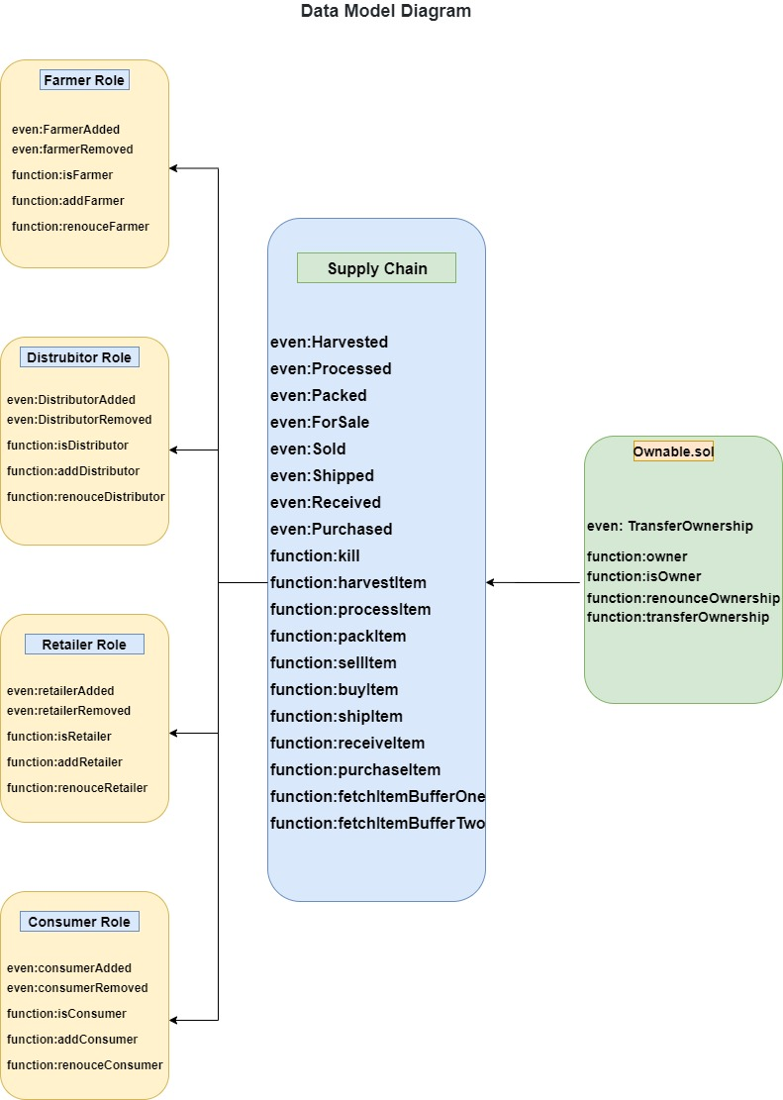

5. OUTCOMES
- Improved Supply Chain Transparency:
  - Trace every product from origin to retailer, ensuring full visibility for all stakeholders.
○ Builds trust among partners, reduces inefficiencies, and mitigates risks such as theft, counterfeiting, and tampering.
- Enhanced Data Security and Integrity:
  - Utilizes blockchain for immutable and tamper-proof data recording.
○ Secures product journeys and enables stakeholders to confidently verify authenticity, reducing fraud and errors.
- Real-Time Monitoring and Decision-Making:
  - Enables real-time tracking of product status, environmental conditions, and location through IoT sensors and RFID/NFC tags.
○ Facilitates immediate action on issues (e.g., temperature deviations, delivery delays) and uses predictive analytics for forecasting supply chain disruptions.
- Increased Efficiency and Cost Reduction:
  - Automates data collection, reducing manual intervention and minimizing human error.
○ Optimizes routes and improves inventory management, cutting operational costs and saving time.
- Consumer Trust and Product Verification:
  - Allows consumers and retailers to verify the origin, authenticity, and quality of products.
○ Particularly beneficial for high-value or perishable goods, where quality and authenticity are critical.
i

6. TIMELINE OF THE PROJECT/ PROJECT EXECUTION PLAN
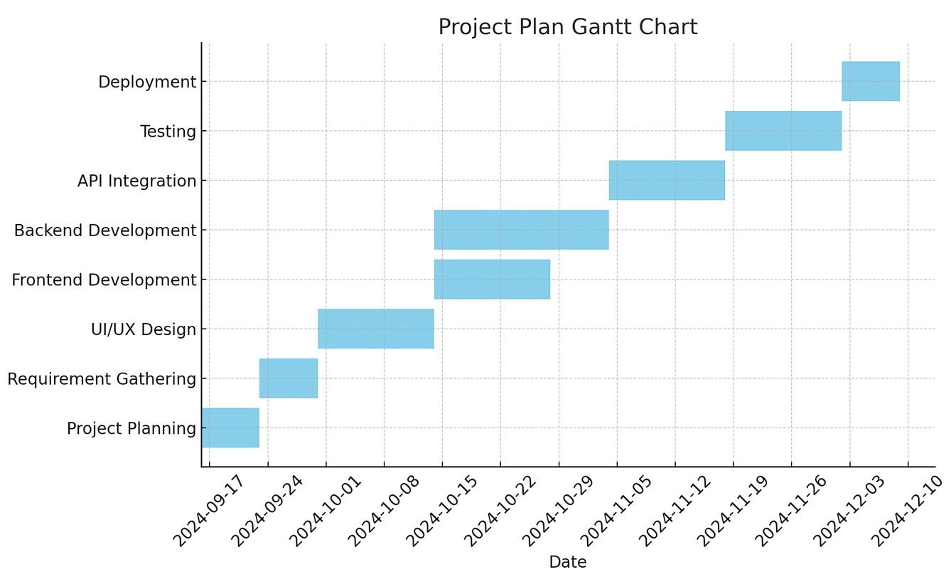

7. CONCLUSION
The Track and Trace Supply Chain project delivers a comprehensive solution for real-time product tracking, enhancing transparency and security throughout the supply chain. By integrating IoT, RFID/NFC, and blockchain technologies, the system provides end-to-end visibility, enabling stakeholders to monitor products from manufacturing to retail. Automation minimizes human error and operational costs, while blockchain guarantees data integrity and trust. The expected outcomes—improved transparency, real-time decision-making, and increased consumer trust—position this solution as a transformative approach in modern supply chain management. Its scalable and secure infrastructure can be adapted across various industries, promoting greater efficiency, security, and accountability.

8.REFERENCES
- Track and Trace in Pharmaceutical Industry
Title: Securing the Pharmaceutical Supply Chain
Authors: Koh R., Schuster E. W., Chackrabarti I., Bellman A.
Published: 2003
Link: Securing the Pharmaceutical Supply Chain
Summary: This paper focuses on how track and trace systems can secure the pharmaceutical supply chain against threats such as counterfeit drugs and theft by introducing serialization and anti-counterfeiting measures.
- Global Drug Traceability Mandates
Title: Global Drug Traceability Mandates: Why Act Now?
Author: Daleiden B.
Published: 2009
Link: Global Drug Traceability Mandates
Summary: This article discusses global regulations that mandate traceability for pharmaceutical products, focusing on emerging requirements and their impact on manufacturers.
- Emerging Technologies in Supply Chain
Title: Emerging Traceability Technologies as a Tool for Quality Wood Trade Authors: Tzoulis I., Anreopoulou Z.
Published: 2013
Journal: Procedia Technology
Summary: While focusing on the wood industry, this paper explores traceability technologies like RFID and barcode systems that can be applied in other sectors such as pharmaceuticals and food, emphasizing quality assurance and traceability.
- Anti-Counterfeiting in Supply Chain Title: Pharmaceutical Counterfeiting Author: Deidingh A.K.
Published: 2004
Link: Pharmaceutical Counterfeiting
Summary: This article provides insights into anti-counterfeiting measures in the pharmaceutical supply chain and the role of track and trace systems.
- RFID in Supply Chain
Title: Applications of RFID in Pharmaceutical Industry Authors: Potdar M., Chang E., Potdar V.
Published: 2006
Conference: IEEE Conference on RFID Technology
Summary: The paper discusses the use of RFID in pharmaceuticals for real-time tracking, serialization, and improving the overall traceability of products through the supply chain.
- Track and Trace in Food Industry
Title: Advanced Traceability Systems in Aquaculture Supply Chain
Authors: Parreño-Marchante A., Alvarez-Melcon A., Trebar M., Filippin P.
Published: 2014
Journal: Journal of Food Engineering
Summary: This article explores the implementation of advanced traceability systems in the food supply chain, with a focus on the aquaculture industry. Concepts can be extended to pharmaceuticals and other supply chains.
- Regulatory Compliance and Supply Chain Optimization
Title: Impact of RFID, EPC and B2B on Traceability Management of the Pharmaceutical
Supply Chain
Authors: Barchetti U., Bucciero A., De Blasi M., Guido A.L., Mainetti L., Patrono L.
Published: 2010
Conference: IEEE International Conference on RFID – Technology and Applications
Summary: The paper examines the benefits and challenges of integrating RFID and Electronic Product Code (EPC) for traceability in the pharmaceutical supply chain, with an emphasis on B2B optimization.
- Continuous Traceability with GPS
Title: GPS-based Track and Trace for Transparent and Sustainable Global Supply Chains Authors: Kandel C., Klumpp M., Keusgen T.
Published: 2011
Journal: Proceedings of the 17th International Conference on Concurrent Enterprising (ICE) Summary: The article covers the implementation of GPS-enabled track and trace systems in global supply chains, emphasizing transparency and sustainability.
ThankYou

